
DEPARTMENT OF COMPUTER SCIENCE AND ENGINEERING
DDL Commands – CREATE, ALTER, DROP EXPERIMENT
Ex. No.: 1
AIM:
To Create, Alter, Drop, Rename and Truncate tables using Data Definition Language (DDL) statements.

DESCRIPTION:
Data Definition Language (DDL) statements are used to define the database structure or schema.
DDL Commands:
- CREATE – Creates database objects such as tables.
- ALTER – Modifies the structure of an existing table.
- DROP – Deletes a table from the database.
- TRUNCATE – Removes all records from a table.
- RENAME – Renames a table.

SYNTAX
CREATE TABLE
CREATE TABLE table_name
(
column_name1 datatype, column_name2 datatype, column_name3 datatype,
...
);

ALTER TABLE
Add a Column
ALTER TABLE table_name
ADD column_name datatype;
Drop a Column
ALTER TABLE table_name
DROP COLUMN column_name;

DROP TABLE
DROP TABLE table_name;

TRUNCATE TABLE
TRUNCATE TABLE table_name;

RENAME TABLE
RENAME TABLE old_table_name TO new_table_name;

QUESTIONS
1) Create a table named HOSTEL_ROOMS with the following structure.
S.No | Column Name | Description | Data Type
1 | RoomID | Room Identifier | INT
2 | RoomNumber | Room Number | VARCHAR(10)
3 | BlockName | Hostel Block Name | VARCHAR(20)
4 | FloorNo | Floor Number | INT
5 | RoomType | Room Type | VARCHAR(20)
6 | Capacity | Maximum Capacity | INT
7 | OccupiedBeds | Occupied Beds | INT
8 | RentPerMonth | Monthly Rent | DECIMAL(8,2)
9 | RoomStatus | Room Status | VARCHAR(15)
10 | WardenName | Warden Name | VARCHAR(50)
Answer
CREATE DATABASE IF NOT EXISTS HostelDB;

USE HostelDB;

CREATE TABLE Hostel_Rooms
(
RoomID INT PRIMARY KEY,
RoomNumber VARCHAR(10),
BlockName VARCHAR(20),
FloorNo INT,
RoomType VARCHAR(20),
Capacity INT,
OccupiedBeds INT,
RentPerMonth DECIMAL(8,2),
RoomStatus VARCHAR(15),
WardenName VARCHAR(50)
);
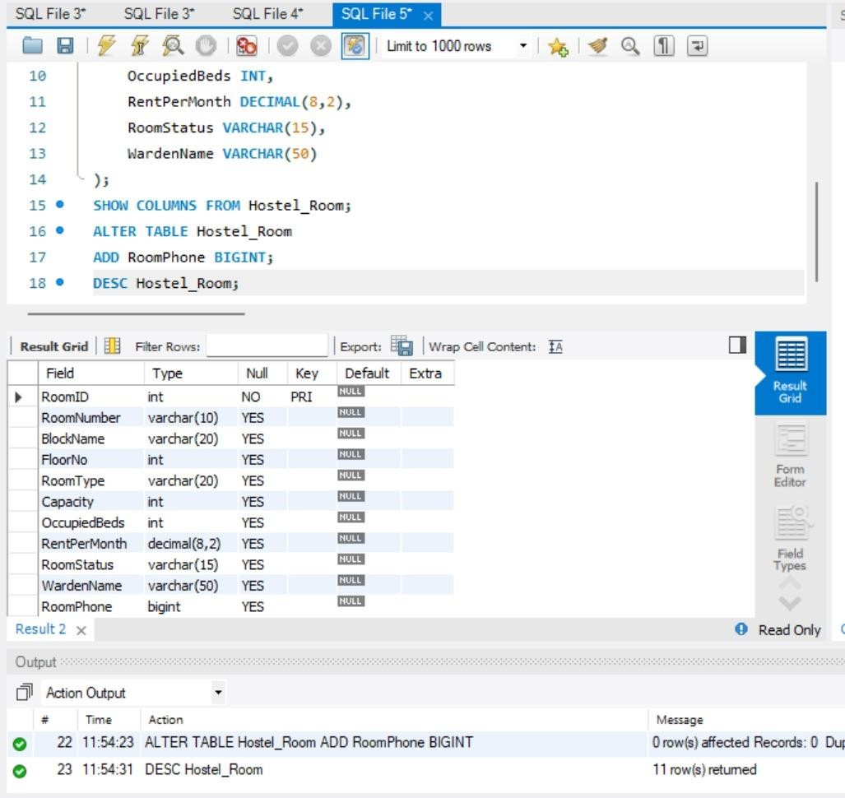

- Create a table named HOSTEL_STUDENT with the following structure.
S.No | Column Name | Description | Data Type
1 | StudentID | Student Identifier | INT
2 | StudentName | Student Name | VARCHAR(30)
3 | Gender | Gender | CHAR(1)
4 | DOB | Date of Birth | DATE
5 | MobileNo | Mobile Number | BIGINT
6 | RoomID | Room Identifier | INT
Answer
CREATE TABLE Hostel_Student
(
StudentID INT PRIMARY KEY,
StudentName VARCHAR(30),
Gender CHAR(1),
DOB DATE,
MobileNo BIGINT,
RoomID INT
);
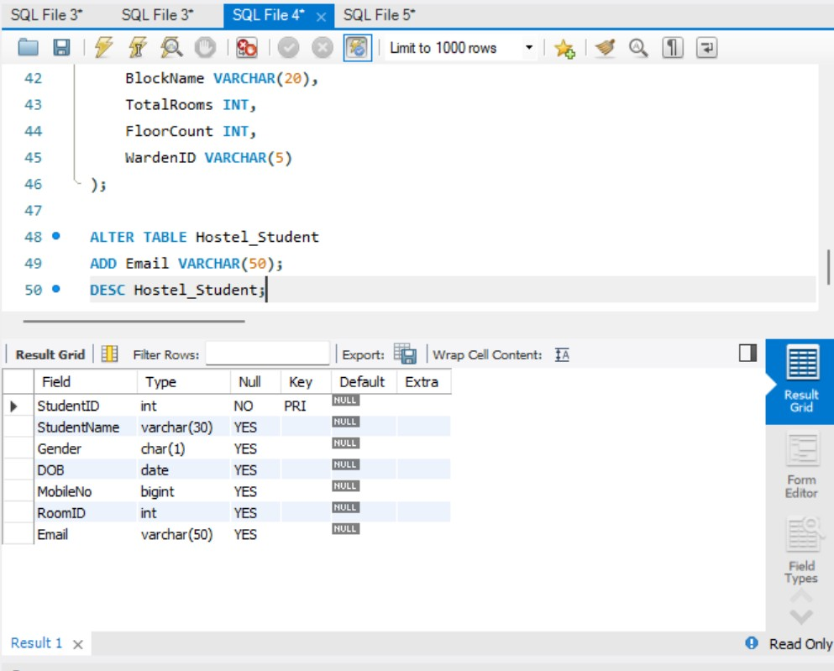
- Create a table named HOSTEL_WARDEN with the following structure.
S.No | Column Name | Description | Data Type
1 | WardenID | Warden Identifier | VARCHAR(5)
2 | WardenName | Warden Name | VARCHAR(30)
3 | Gender | Gender | CHAR(1)
4 | MobileNo | Mobile Number | BIGINT
5 | Experience | Years of Experience | INT
Answer
CREATE TABLE Hostel_Warden
(
WardenID VARCHAR(5) PRIMARY KEY,
WardenName VARCHAR(30),
Gender CHAR(1),
MobileNo BIGINT,
Experience INT
);
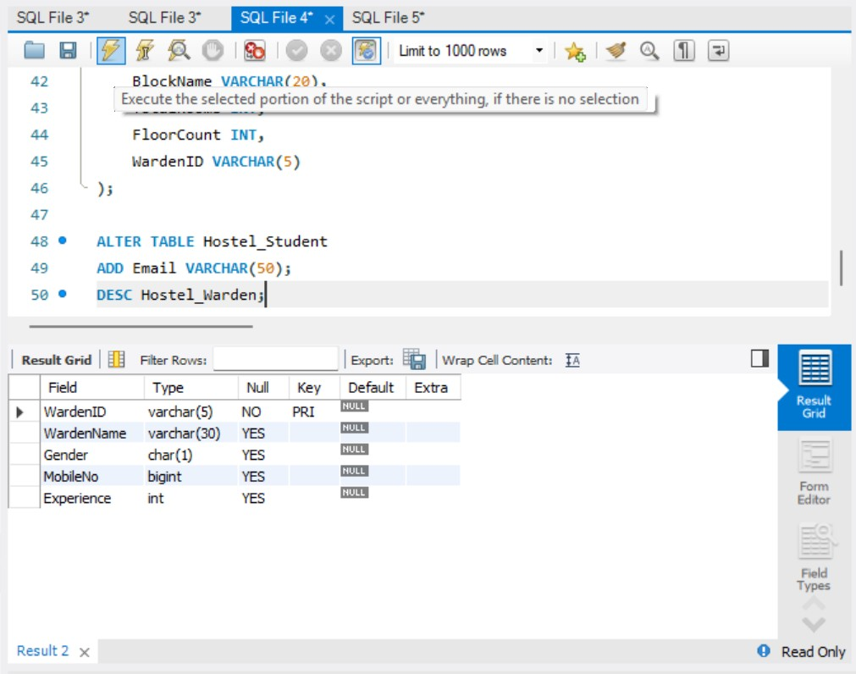
- Create a table named HOSTEL_BLOCK with the following structure.
S.No | Column Name | Description | Data Type
1 | BlockID | Block Identifier | VARCHAR(5)
2 | BlockName | Block Name | VARCHAR(30)
3 | TotalRooms | Total Number of Rooms | INT
4 | FloorCount | Number of Floors | INT
5 | WardenID | Warden Identifier | VARCHAR(5)
Answer
CREATE TABLE Hostel_Block
(
BlockID VARCHAR(5) PRIMARY KEY,
BlockName VARCHAR(30),
TotalRooms INT,
FloorCount INT,
WardenID VARCHAR(5)
);
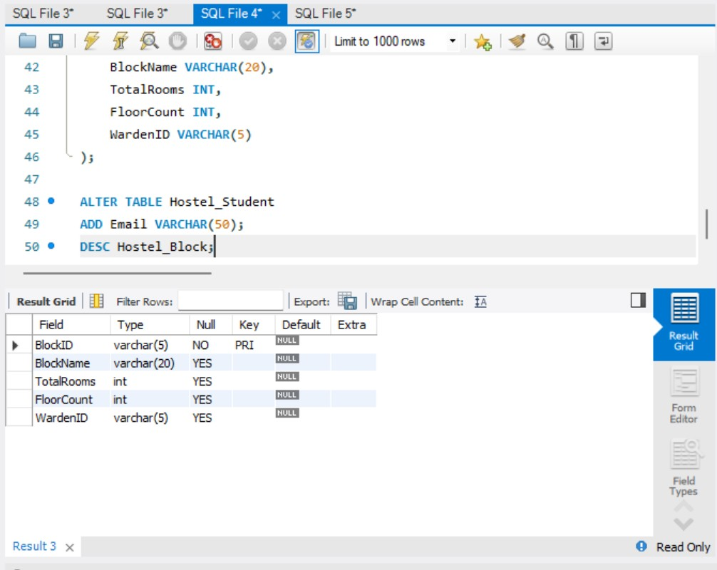
- Modify the table HOSTEL_STUDENT by adding a column named Email of datatype VARCHAR(50).
Answer
ALTER TABLE Hostel_Student
ADD Email VARCHAR(50);

Additional DDL Commands
Rename Table
RENAME TABLE Hostel_Block TO Hostel_Blocks;

Truncate Table
TRUNCATE TABLE Hostel_Blocks;

Drop Table
DROP TABLE Hostel_Blocks;
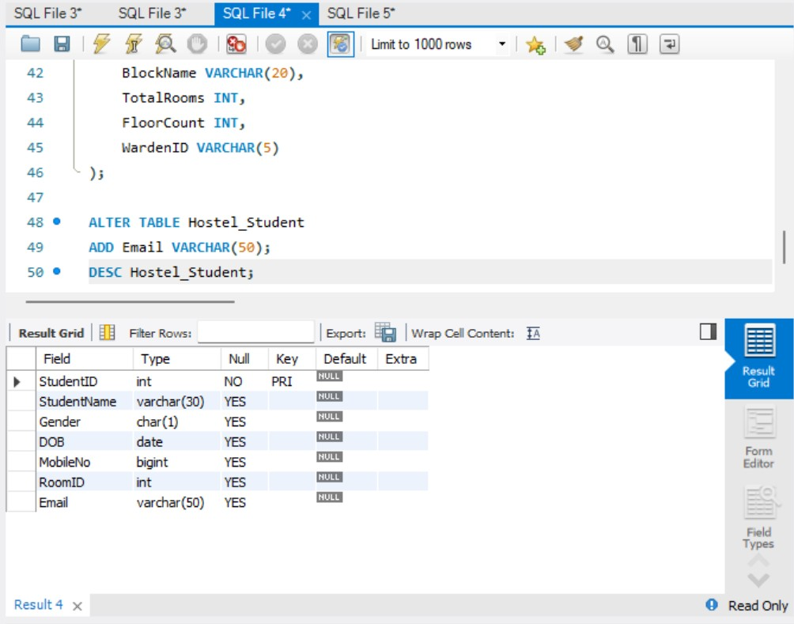
RESULT
Thus, the Data Definition Language (DDL) commands CREATE, ALTER, RENAME, TRUNCATE, and DROP were successfully executed on the Hostel Management System tables in MySQL.

